TransAccess
Document Management
HUD Single Sign On

July 9, 2014.

Objective:
This document describes the HUD’s Single Sign-On (SSO) feature with TransAccess application. This document will help the users to understand the SSO feature and the changes to the login process in TransAccess.

Use Case Steps:
- Click on the following TransAccess URL.

TransAccess URL: www.hudtransaccess.us

Login screen has the following features. Each feature will be explained in detail in the following sections.
- HUD users with a valid HUD credentials using hud.gov email and registered with TransAccess will be able to use the SSO to access the application.
- Other users like HUD OIG who are registered with TransAccess will be to access the application using their TransAccess User Login Id and Password. Forgot password can be used to reset the TransAccess password.
- All users, HUD or others have to be registered in TransAccess and can be done initially using the New User Registration.

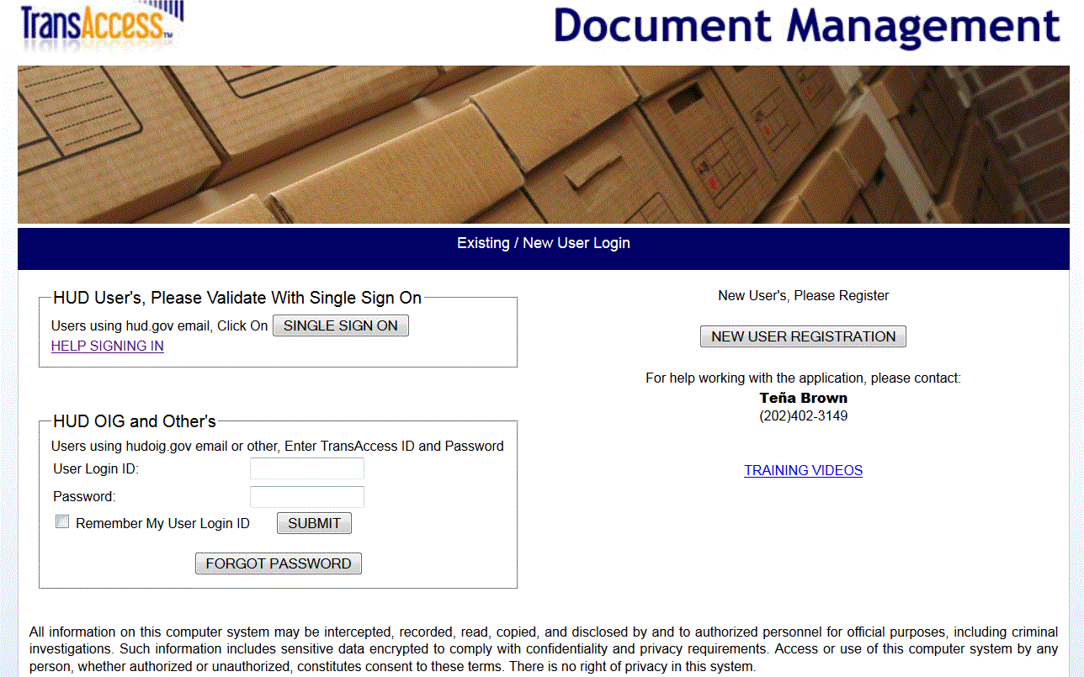

- HUD Single Sign-On (SSO):

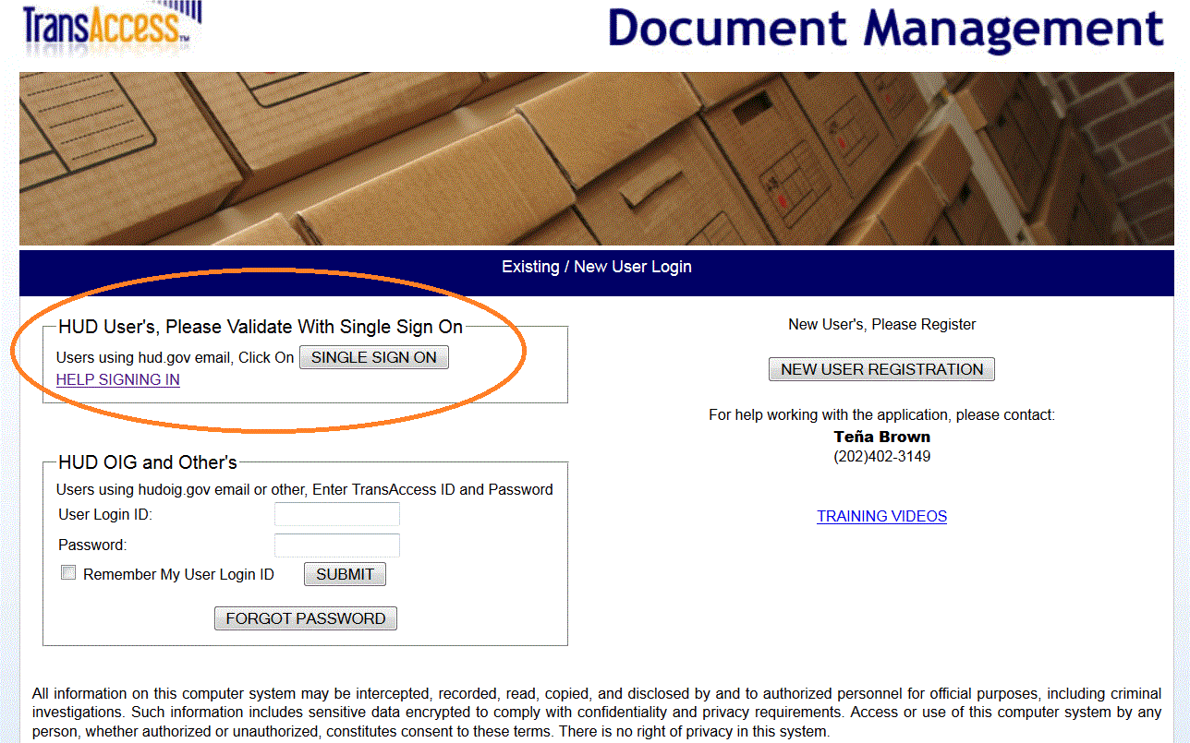

HUD users with valid HUD credentials, using a hud.gov email and an existing TransAccess registration will be able to use SSO.
HUD users will click the SINGLE SIGN ON button. The user will be able to proceed directly to the TransAccess Home page without signing with a user id and password as it will use the SSO to validate the user.
SSO will only work for HUD Users who have already registered in TransAccess.

- New User Registration:

All users accessing TransAccess application has to register once.
In order to register, Click on the NEW USER REGISTRATION button on the login screen.
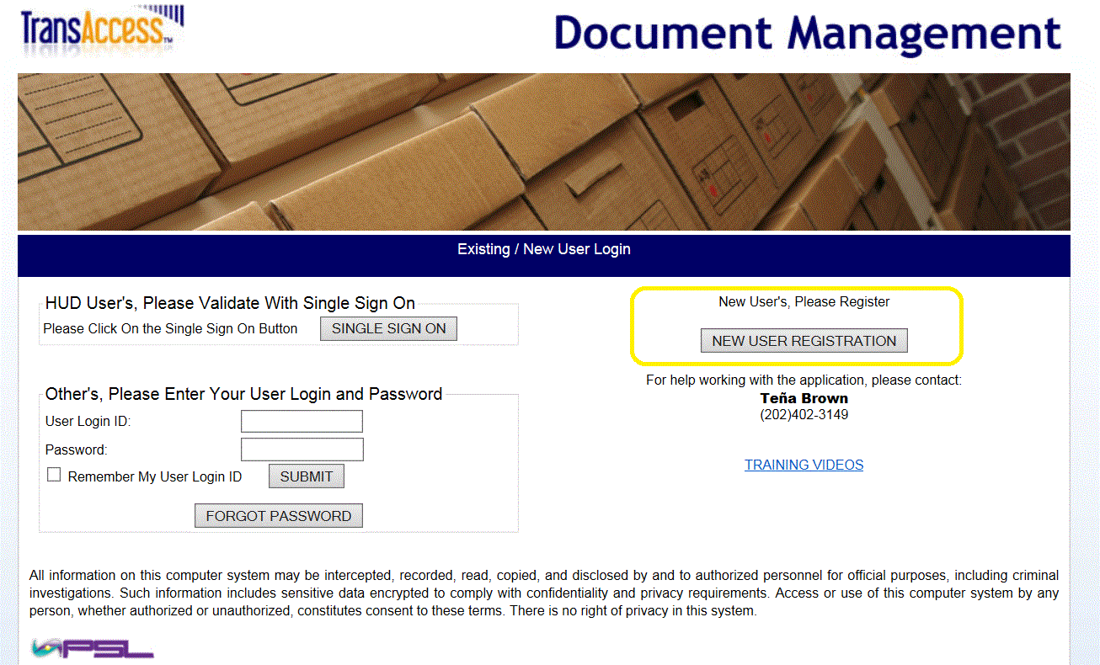

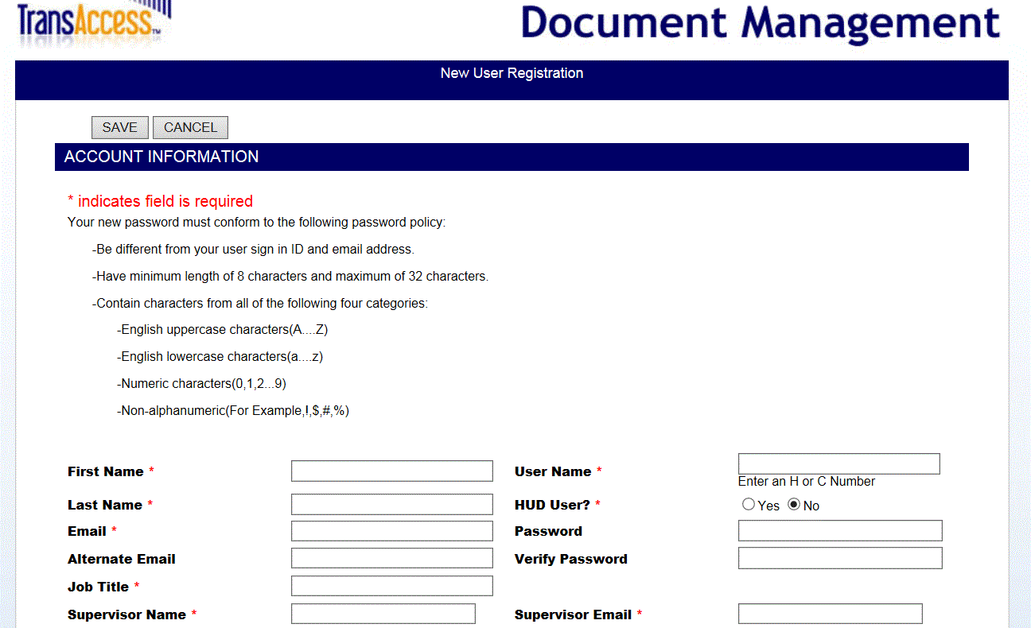

A new HUD user will register by selecting HUD User option as Yes. By default this option will be selected as Yes. Password and Verify Password inputs will be disabled for HUD users. HUD users will be using their HUD credentials with SSO to login to TransAccess and hence don’t need to store and remember a separate password for TransAccess application.
All other users will select HUD User option as No and will need to enter Password and Verify Password as required fields. Non HUD users will need to enter this Password along with User Id to login to the application.

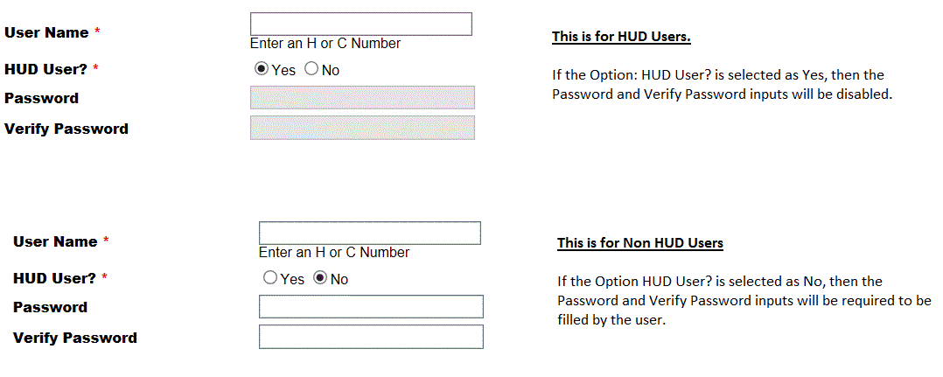

- Non HUD users login:
All other users (HUD OIG and others) who access TransAccess to order/request HUD Case binders from NARA will login using their login Id and Password as stored during initial registration process. Forgot Password button can be clicked to reset password for non HUD users.